Latin America Geography Graphic Organizer

Gulf of Mexico

Arm of the Atlantic Ocean cradled by Mexico and the southern US coastline from Texas to Florida. The Mississippi and Rio Grande are two major rivers .

Sierra Madre Mountains

The main mountain ridge in Mexico. It has three major chains. The Occidental in the west, Oriental in the east and del Sur along the southern coast

Caribbean Sea

An arm of the Atlantic Ocean between Cuba and South America. Islands of the Caribbean are popular with tourist because of the beautiful beaches and mild tropical climate.

Panama Canal

Is a canal built through the Isthmus of Panama at the narrowest point to allow ships to pass between the Atlantic and Pacific Oceans.

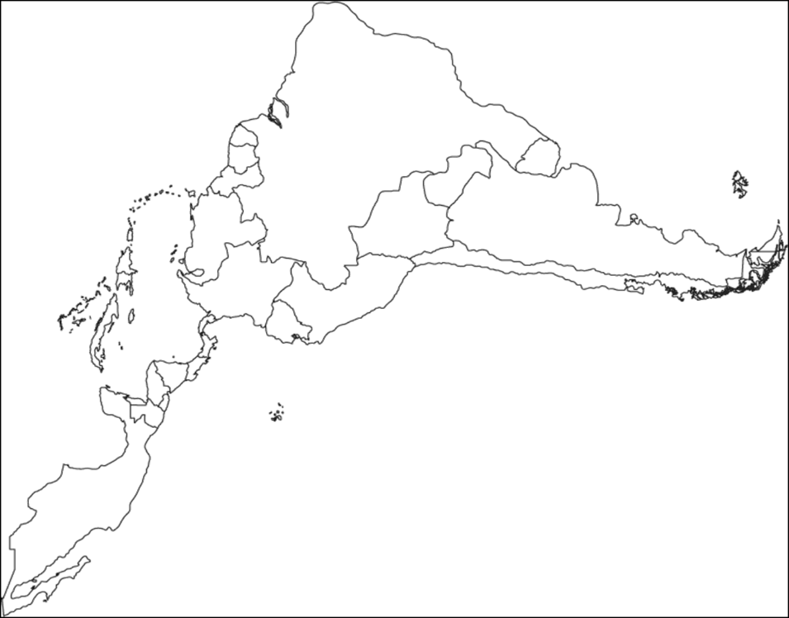

Amazon River

2nd largest river in the world flows mainly through Brazil in South America. It carries the greatest volume of water of any river in the world

Atacama Desert

Known as the driest place on earth. It is at a high elevation along the coast of Chile. The average temperature is cold. Some parts have never had any rain

Andes Mountains

Chain of mountains along the western edge of South America. It is the longest continuous mountain range in the world

Amazon River, Caribbean Sea

Gulf of Mexico

Pacific Ocean

Panama Canal

Andes Mountains

Sierra Madre Mountains

Atacama Desert

Pacific Ocean

is the largest and deepest of the world’s five oceans and borders Latin America to west

.

Bolivia Brazil Colombia Cuba Haiti Mexico Panama Venezuela